Math 4 Name_______________________________

**5-3 Learn Check** Date________

*In this Learning Check, you will be assessed on the following learning goals:*

*I can use the definition of derivative to compute derivatives*

*I can use derivatives and their graphs to identify properties of functions*

1a. Let *f* be the function . Use the *definition of derivative* to find.

1b Find the slope of the tangent line to *f*(*x*) at *x =* -8.

1c. Is *f* increasing or decreasing when *x =* -8? Justify your answer.

2. A projectile follows along a path given by the formula . The derivative

function for is  (*t* in seconds, *h*(*t*) in feet). Answer the questions below based on the functions.

2a. Find the instantaneous velocity when *t =* 20. Explain what your answer means about the

projectile.

2b. Find the instantaneous velocity when *t =* 8. Explain what your answer means about the

projectile.

2c. Find the instantaneous velocity when *t =* 15. Explain what your answer means about the

projectile.

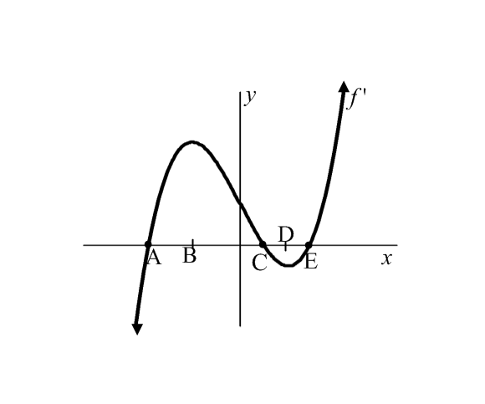**Below is a graph of (*the derivative function*). Use the graph to answer Questions 5-7.**

*Remember, the derivative is the instantaneous rate of change at a specific x-value.*

3. Use the letters A, B, C, D, and E to describe on which interval(s) the graph of  is increasing?

4. Use the letters A, B, C, D, and E to describe on which interval(s) the graph of  is decreasing?

5. What do the *x-*intercepts of ****tell you about the graph of ?

Use the graph of ****below to estimate the value of the derivative at the given points.

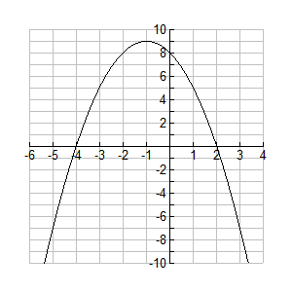

6. 

7. 